Alexander Cannell

CSIA 6200

Professor Rob Robertson

3/4/2016

Physical Security Assessment (PSA) Plan:

**My Contributions:**

I like what Jared posted. I feel this is going to be like our vulnerability assessment 1.0. Everything I have been looking at in regards to Physical security assessment involves some sort of incidence response team for both physical and cyber domains. I think our assessment should include a formation and roles of incident response team. <http://www.bankinfosecurity.com/how-to-perform-physical-security-risk-assessment-a-694/op-1>

<http://www.sans.org/reading-room/whitepapers/incident/creating-managing-incident-response-team-large-company-1821>

<http://modulo.com/security-risk-management/>

(Alexander Cannell)

Honestly I feel like we are going back to the four essential steps we listed in the previous VAM Module Identify, Analyze, Mitigate, and Manage.

1. Identify
   1. Threat Identification
   2. Asset Assessment
      1. Inventory of current assets
      2. Value of assets
      3. Rank asset
2. Analyze
   1. Analyze activities/traffic and form baselines for ‘normal’
   2. Monitor for vulnerabilities, compromises, departures from ‘normal’
   3. Perform penetration testing
   4. Risk Assessment
3. Mitigate
   1. Take measures to fix problems found
   2. Alter policies if needed
4. Manage
   1. Document changes
   2. Assess implemented fixes and monitor to ensure their success
   3. Repeat steps when needed

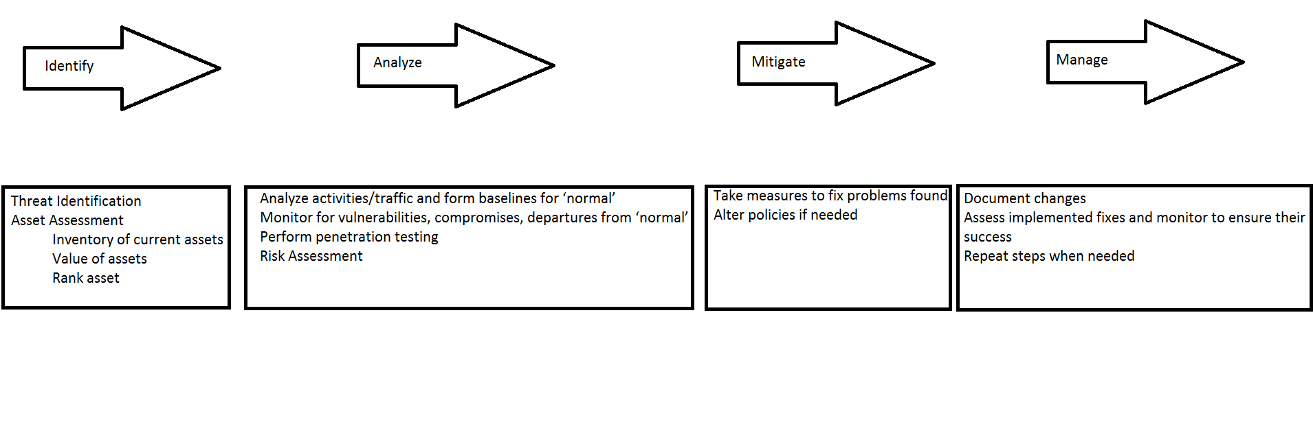(Alexander Cannell)